Suppression output in the viewer in SPSS using OMS

General idea:

OMS

/SELECT TABLES

/IF COMMANDS=['Generalized Linear Mixed Models']

SUBTYPES=['FixedCoefficients' 'CaseProcessingSummary']

LABELS=['Fixed Coefficients']

/DESTINATION VIEWER=NO

.

<<< command >>>

OMSEND

.

To see what is needed to fill in, there are several options. Easiest is:

* select in the left pane of the output viewer, the part of the output you want to exclude
* right click and use the “Copy OMS Command Identifier/Table Subtype/OMS label” to exclude

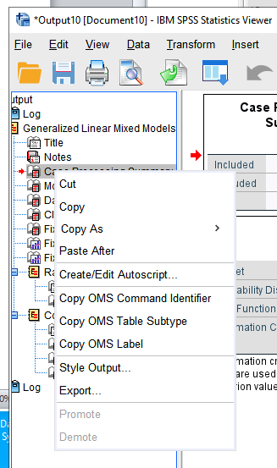

* it does not delete graphics in the output (such as the model viewer in SPSS) though.